4.9 Exercise 2 – condensation polymers

- Predict the products of the following reactions:

- benzene-1,4-dicarboxylic acid with 1,2-diaminoethane
- hexane-1,6-dioyl chloride with propan-1,2-diol
- ethanedioic acid with ethan-1,2-diol

- From what monomers can the following condensation polymers be made:

a) terylene

b) nylon 66

c)
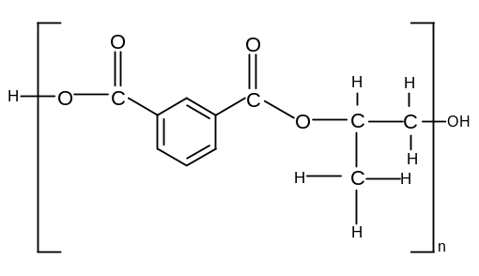

d)
